after | again | an
any | as | ask
by | could | fly

from | give | giving
had | has | her
him | his | how

just | know | let
live | may | of
old | once | open

over | put | round
some | stop | take
thank | them | then
think |  | were
when |  | walk

Purple minion: Lose a turn | Purple minion: Lose a turn | Purple minion: Lose a turn
Purple minion: Lose a turn | Purple minion: Lose a turn | 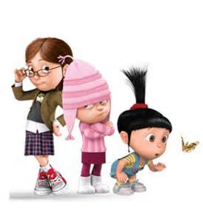  Extra turn!
Extra turn! | Extra turn! | Extra turn!

