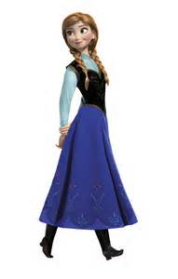  after | 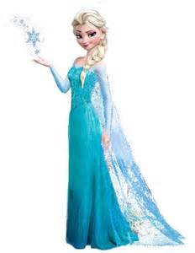  again | 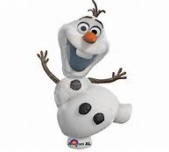  an
any | as | ask
by | could | fly

from | give | giving
had | has | her
him | his | how

just | know | let
live | may | of
old | once | open

over | put | round
some | stop | take
thank | them | then
think | walk | were
when

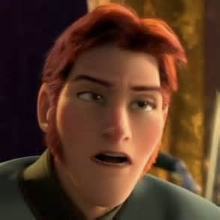  Prince Hans: Lose a turn | Prince Hans: Lose a turn | Prince Hans: Lose a turn
Prince Hans: Lose a turn | Prince Hans: Lose a turn | 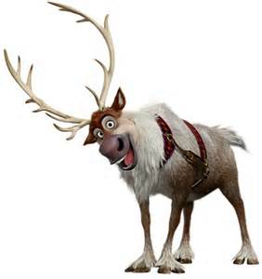  Sven: Extra turn!
Sven: Extra turn! | Sven: Extra turn! | Sven: Extra turn!

