Text Features
Lesson
Topic Index | Grade 4 ELA | Elementary Test Prep | StudyZone

Text features can help you to  gather and use information. | 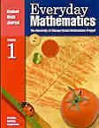
Know how to use the features of your textbook.
* Table of Contents
* Headings
* Subheadings
* Charts
* Illustrations
* Captions
* Vocabulary
* Glossary

Table of Contents - Identifies the chapters in the textbook
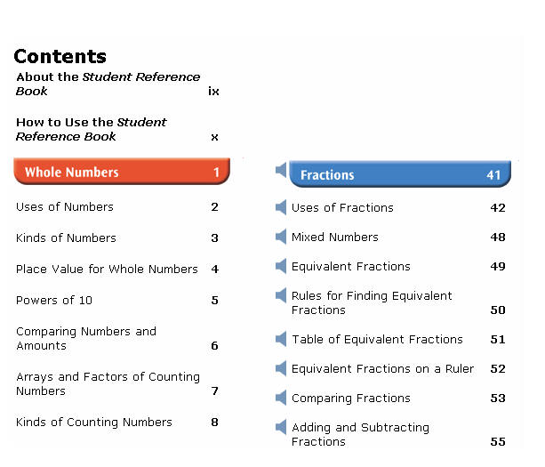

Heading - Identifies the topic of a text section
Subheading - Identifies additional topics under a heading
Heading→  Subheading→ | 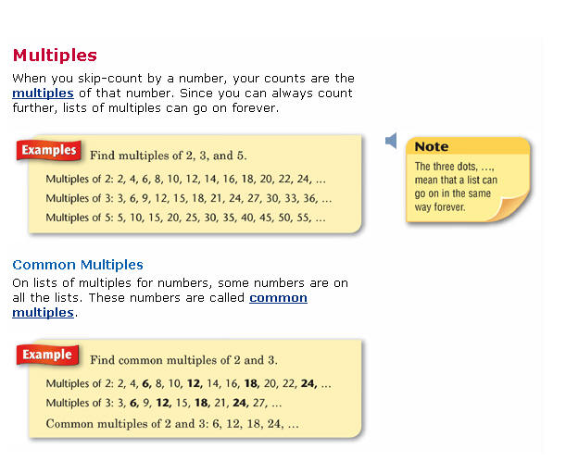
Vocabulary - Words that are important or particular to the topic
Illustration - A picture to accompany a topic
Caption - A sentence that identifies an illustration
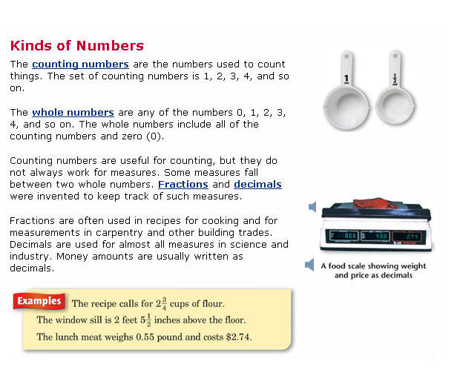 | ← Vocabulary  ← Illustration  ← Caption

Glossary - a "dictionary" of terms found in the text
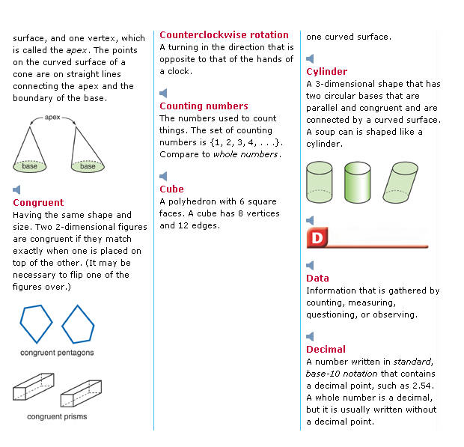

Chart - a diagram containing information relating to the topic
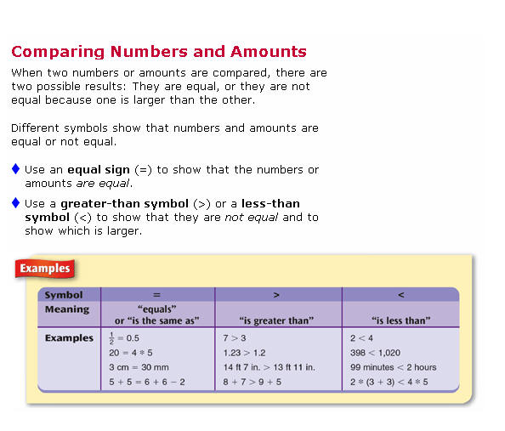 | ← Chart

Remember: | Know how to use text features.

Click on the books for practice.
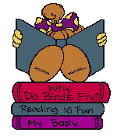
Topic Index | Grade 4 ELA | Elementary Test Prep | StudyZone
Created by Pat Delia
Copyright © 2001-08 Oswego City School District

